**ResLog Application Requirements**

**Contents**

1 Issue and Amendment Record 3

2 Purpose 3

3 Overview 3

4 Other Documents Included As Part of This Specification 4

5 Detailed Specifications 5

5.1 Database ResLogB08 5

5.1.1 Access Table Locations 5

5.1.2 Access Table Details 5

5.1.3 List of Tables 6

5.1.4 Table Relationships 7

5.1.5 List of Forms 9

5.1.6 Initial Form of Application 10

5.1.7 Assembly Form Flow 11

5.1.7.1 Operation Tab 11

5.1.7.2 Wrapping Tab 12

5.1.7.3 Machine generated alternative text: BOM Tab 12

5.1.7.4 Status Tab 13

5.1.8 Slot Data Form Flow 14

5.1.8.1 Slot Import Tab 14

5.1.8.2 Slot Results Tab 15

5.1.8.3 Large Slots Tab 15

5.1.8.4 Section and Angle Details Tab 16

5.1.8.5 ID Summary Tab 16

5.1.9 Order Planning Form Flow 17

5.1.9.1 Order Tab (Plus Order New & WO New) 17

5.1.9.2 Product Details Tab 18

5.1.9.3 Operations Tab 19

5.1.9.4 MFG Tests Tab 19

5.1.9.5 Work O. BOM Tab 20

5.1.9.6 Slot Requirements Tab 21

5.1.9.7 Report Setup Tab 21

5.1.10 QC/Admin Form Flow 22

5.1.10.1 ID Status Tab 22

5.1.10.2 Edit ID Tab 22

5.1.10.3 SN Status Tab 23

5.1.10.4 Pull Off Tab 24

5.1.10.5 Harness Tab 25

5.1.10.6 Reports Tab 26

5.1.10.7 Slot Summary Tab 27

5.1.10.8 Ship Tab 28

5.1.10.9 Parts Allocated Tab 29

5.1.11 Ware House Form Flow 30

5.1.12 Module RLFunction 31

6 Project Plan 32

6.1 Development Plan 32

6.2 Development Milestones 32

7 Risks 32

# 

# Issue and Amendment Record

|  |  |  |  |
| --- | --- | --- | --- |
| **Issue** | **Date** | **Revised by** | **Comments** |
| 1 | 11 Feb 2013 | James Brotton | First Draft |
|  |  |  |  |
|  |  |  |  |

# Purpose

The details of this document are to be used to provide a reasonable quote for the effort required to move the Microsoft Access ResLog Database application into a .NET framework and into a SQL Server Database.

A preliminary estimate for developing the ResLog application should include two things:

* Time estimate for complete development based on:
  + The details shown in this document
  + Plus the effort to provide User and Technical documentation for the application
* Cost estimate for the complete development
  + The details shown in this document
  + Plus the effort to provide User and Technical documentation for the application

***Important Note:***

*This document is based on the ResLogB08 version of ResLog. The ResLog application is currently being revised by the support staff in the Norway product center. These additional database and functional fixes and modifications have not been included in this document.*

# Overview

ResLog is an Access database developed to track details of the Reslink screen production. It is recording details of each screen joint as it passes through one or more manufacturing steps or operations. The information that can be recorded is:

* Wrapping process details
* Slot opening measurements and verification of slot requirements
* Process inspections and measurements
* Traceability of components

The system is intended to work together with MfgPro, but no automated link is made.

To use ResLog, the following sequences must be completed:

* Planner must enter work order details
* If component traceability is included, ware house operator must allocate parts and enter traceability information
* Operator must record production data

# Other Documents Included As Part of This Specification

|  |  |
| --- | --- |
| ***File Name*** | ***Content*** |
| DocFormCode.pdf | The Code executing behind the forms of the legacy application |
| DocFormProperties.pdf | The Properties of the Forms used in the legacy application |
| DocForms.pdf | The Form Properties, Fields, Code and Data Source of each form |
| Tables.pdf | The field names, field types and field lengths for each table, along with the table relationships for each table |
| ResLog_Bx_UsersGuide_Part1_27Nov2012.docx | ResLog Documentation provided by the support group. |
| ResLog_Bx_UsersGuide_Part2_Sep2012.docx | ResLog Documentation provided by the support group. |
| ResLogB08.mdb | Main ResLog Database |
| ResLogBtbl01.mdb | Part of the ResLog application |
| ResLogBtbl02.mdb | Part of the ResLog application |
| ResLogBtbl03.mdb | Part of the ResLog application |
| RLFunction.txt | Listing of the code contained in the RLFunction module of the ResLog project |

# Detailed Specifications

## Database ResLogB08

### Access Table Locations

|  |  |
| --- | --- |
| **Database** | **Table(s)** |
| ResLogBtbl02-no data | tblSlotData |
| ResLogBtbl03 | tblSlotImp |
| ResLogBtbl01 | All other tables |

### Access Table Details

* Field Names, Types, Lengths
* Relationships by Table
* Indexes

**Please refer to separate file DocTables.pdf**

### List of Tables

Machine generated alternative text: All Access Objects  :
Tables
tblAllocated
tblAnIe
tbIAsBuiItßOM
+ tblAsßuiltOperation
tbIAsuiItTest
tbIAssemby
tbl6ug
tblCsg
tblLocotion
tblMachine
tblOperation
tblOperationBOM
tblOperationTest
tblOperator
tblOrder
tblOrdertine
tblOrdertineßOM
tblProductType
tblReport
tblScanLageSlot
tblScreen
tblScreenType
tblSearch
tblSlotData
• tblSlotFile
tbiSiotlmp
tblSlotReq
tblSlotResult
tblSlotStatistics
tblUnit
tblWareHardness
tblWirePullTest
tblWorkStatiori
tbEWrap
‘ tblWraplength
tblWrapType
Form View

### Table Relationships

Machine generated alternative text: OrderlD
ProdOrder
Customer
Description
LocationlD
Comment
OrderRegDate
OrderRegSign
CompletedDate
CompletedSign
OldOrderID
EndCustomer
ProductTypelD
Pro du ctN ame
Wrapping
WrapWireMass
AxialWireMass
WrapThickness
WrapWireWidth
ScreenTypelD
Screen Name
Wrapping
WrapWireMass
AxialWireMass
WrapThickness
WrapWireWidth
CsgID
PipeOD
PipeWeight
PipeODmm
PipelDmm
AxialRods
PenD
OrderLinelD
Section
StartPos
WrapLength
LengthType
tblOrderLine
OrderLinelD
OrderLD
Comment
WorkOrder
ProductTypelD
ScreenTypelD
Pa rt N o
Rev
Description
QualityPla n
QualityPlanRev
Quantity
MakeUpLoss
SlipElevatorL
To n g L
CollarL
NomScreenOD
BpOD
BpJD
nAxialRods
nPeif orations
WrapWireMass
AxialWireMass
ComponentMass
Pert orationOff set
nPerfcycle
DrillDist
PertDia
DriftlD
DriftOD
SlotOpening
InclOSlot
MaxStdev
InclStdev
NSections
NLines
InclAliLines
InclAllCompleteLines
ExamineSlotAbove
ExamineSlotßelow
ScanLargeSlot
a
C2
1:3
C4
aimes
C2iines
C3Lines
C4 1m e s
OrderLinelD
Pa rtn o
PartRev
Description
UnitID
Qty
Pos
Usage
WrapWire
OperationlD
OldOrderLinelD
OperationlD
OrderLinelD
Ope ratio n N o
Description
MachinelD
SecondSign
SlotReqID
OrderLinelD
SlotRLow
SlotRHigh
SlotRMax
SlotRMin
SlotRDig its
SlotStDevMax
In clRequi rement
AllocatedlD
OrderLineBOMID
Partno
Rev
OrderLinelD
Traceability
SpecialPartlD
Qty
WrapWireWidt
OperationBOMlD
OrderLineBOMID
Qty
WrapWire
OperationlD
HideOperationßOM
OperationlD
OpTestText
OpTestType
MinVal
MaxVaI

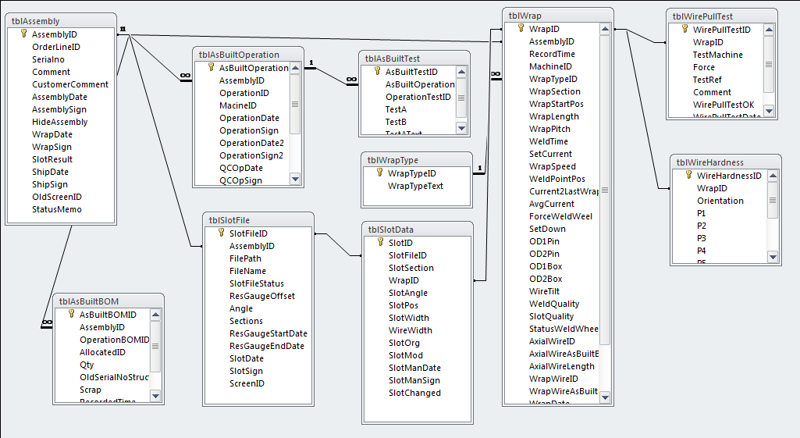

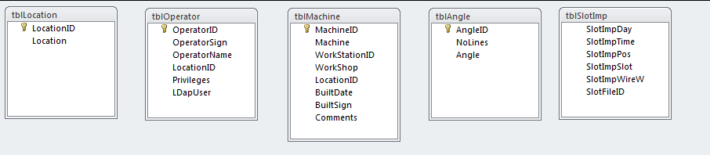

**Note:** The tables listed at the bottom

* tblLocation
* tblOperator
* tblMachine
* tblAngle

should also be included in the relationship structure.

### List of Forms

Machine generated alternative text: Forms
frmAllocated
frmAllocatedUB
frmAsBuiltßOM
frmAsBuiItBOMAII
frmAsBuiltOperationslot
frmAsBuiltOperationWrapping
f rmAc Bu iltTe ctA
frmAsßuiltTestB
3 frmAssembly
frmAssemblyEdit
frmAssemblystatus
frmAssyOpStatus
frmßug
frmlAsßuiltOperation
frmManufacturingUß
frmMfgStepCode
frmNewOperator
frmNewOrder
frmNewWorkOrder
frmNewWrapSection
frmOperation
frmOperationßOM
frmOperationTest
frmOperator
frmOperatorSub
frmOrder
ErmOrderDetail
frmOrderLinel
frmOrderLinebOM
frmOrderLineDetails
frmOrderLineSlot
frmPivSlatStatAll
frmPapulateAllocated
frmProgressBar
frmQC
frmQCWirePullTestMachine generated alternative text: frmQCWrap
frmReportsetup
frmscreen
frmScreenlD
frmship
frmslotoata3l
frmslotoata3List
frmSlotDataA2
frmslotExp
frmSIotExplllll
frmSlotFile
frmslotFileCalc
frmslotFileoata
frmslotFileoetail
frmSlotFilelmport
frmslotlmportAngle
frmSlotlmportWrapSection
frmslotLarge
frmSlotLargell
frmslotOutOfSpec
frmslotReq
f rmSlot Res u It
frmslotStatAll
frmslotStatAllList
frmslotStatistics
f rm SlotStatistics [J st
frmWareHouse
frmWireHardness
frmWirePullTest
frmWrapDetail
frmWrapLength
Start

### Initial Form of Application

Machine generated alternative text: [ResLog’ = Si £3
ReiIink
a 5th un*qrur maai
Release date 27 Nov 2012
Production log VPFSìOnRI7L9
Assembly Report a Bug
Slot Data Operators
Order
QO/Admiri
Ware House

### Assembly Form Flow

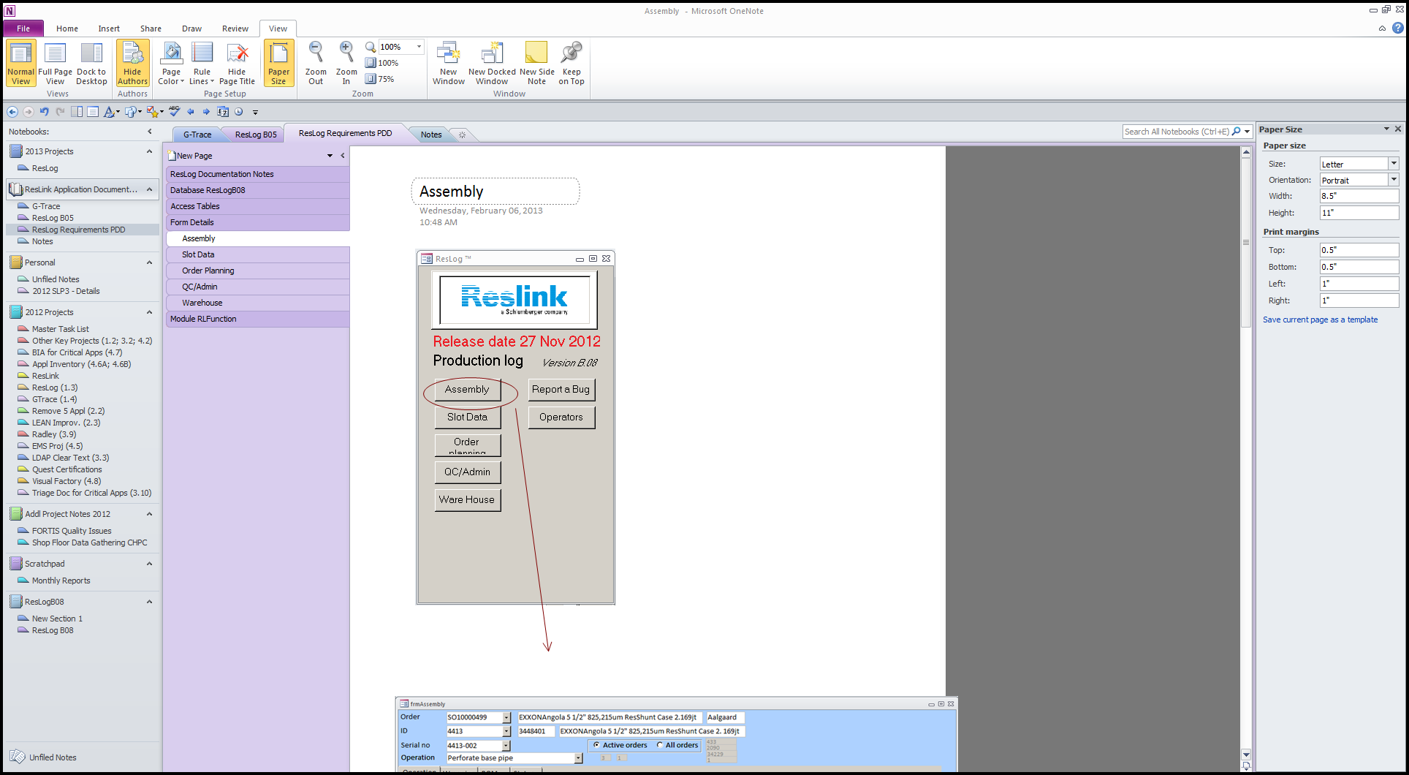

#### Operation Tab

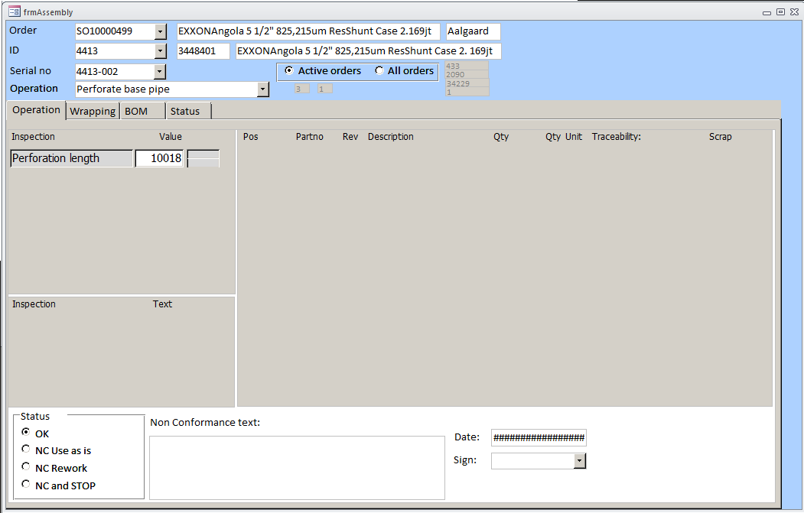

#### Wrapping Tab

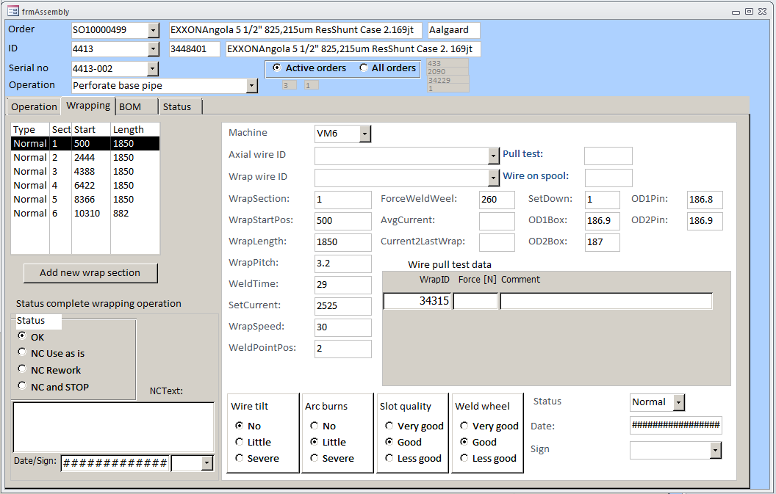

Screen clipping taken: 2/6/2013 1:20 PM

#### Machine generated alternative text: BOM Tab

Machine generated alternative text: Qty Unit Traceability: Scrap
110012343/1/ [/iasffiieu-3
! J12345678/123/12/ABCDEFGHIJKL
1101/I/ac-S
ltest4-sfjh
I 12345678/123/11/ABD123456787-12
110101010/123/12/ 123ABC456788-30
frmAssembly
Order
ID
Serial no
Operation
TestTMl Test Order 123 TM Aalgaard
Test 123 TM 123123123 Test TM - GeMS description
t4-1278436 z] ( Active orders r All orders’
Perforate base pipe
operationj Wrapping BOM [status I
Partno Rev Operation Description
base pipe
Pos
E-i-F
Eli
EN
EF
rt
Eli
Eli
Welding
1Testl
900123123 1M
900234234 lAi
900245245 ¡AC
900245246 144G
900345345 lAD
900456456 JAE
900457457
Welding 1Test3 I
[
1 IP
1 IPcs
J Wrap screen
‘Wra screen
1Wdth 1Test3-ALT Pcs
Vikle
Welding ltest4 I  I1s
[
22.6 JKg
78.7 jkii
r
r
r
r
r
r
r

#### Status Tab

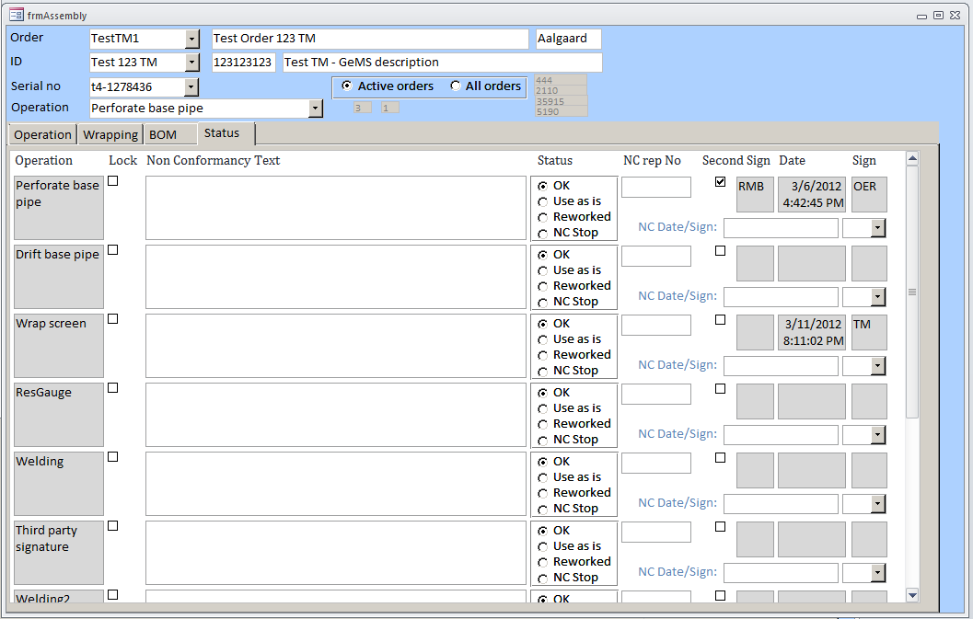

### Slot Data Form Flow

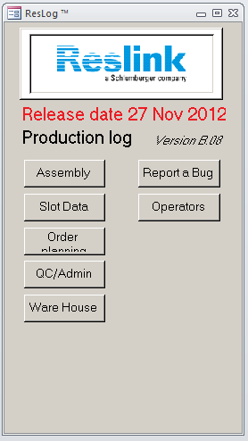

#### Slot Import Tab

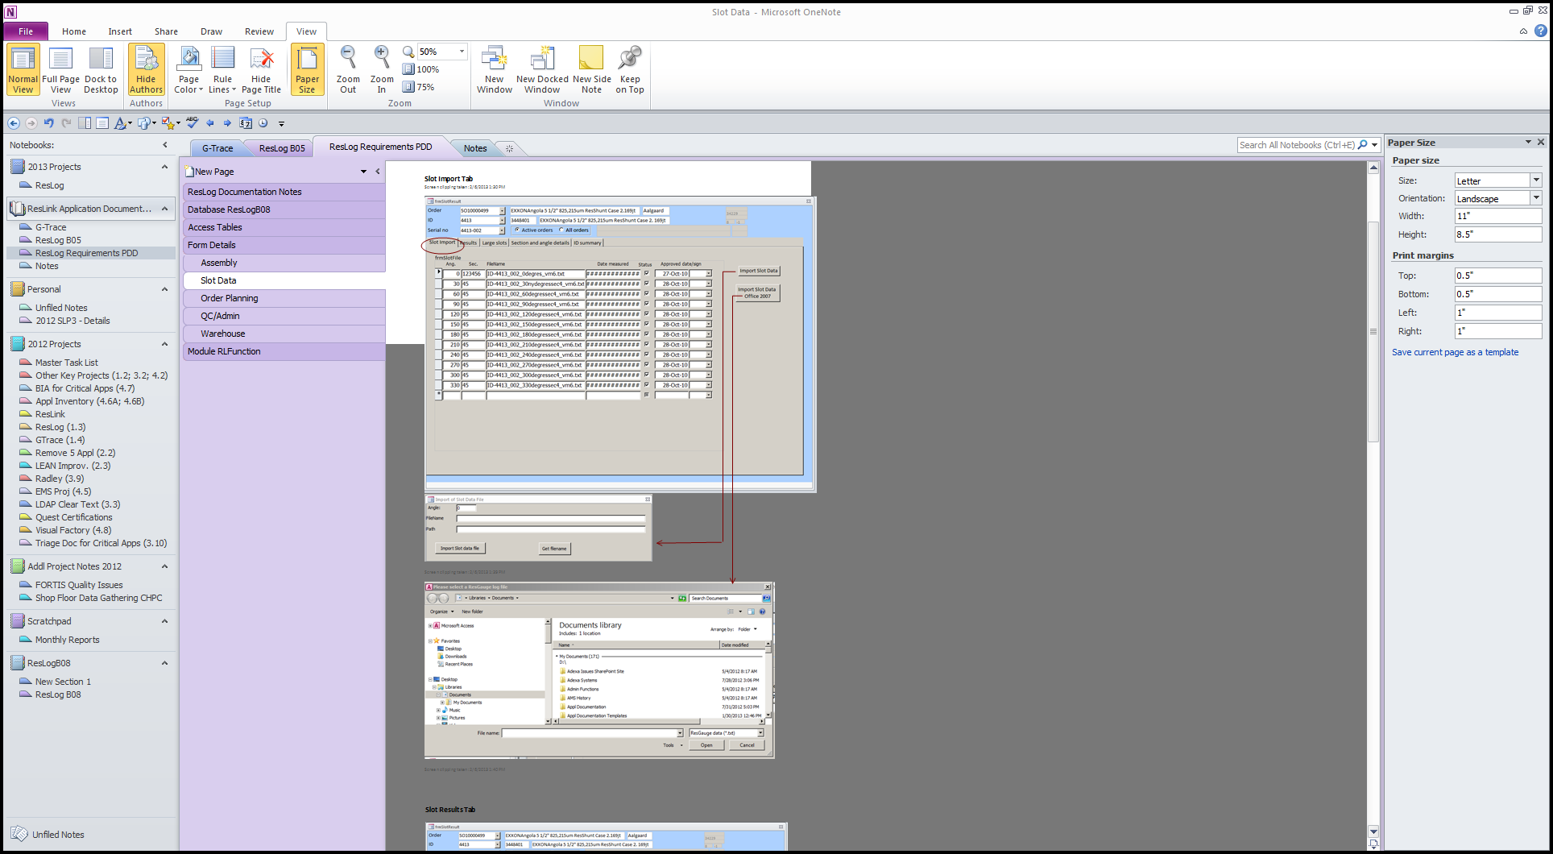

#### Slot Results Tab

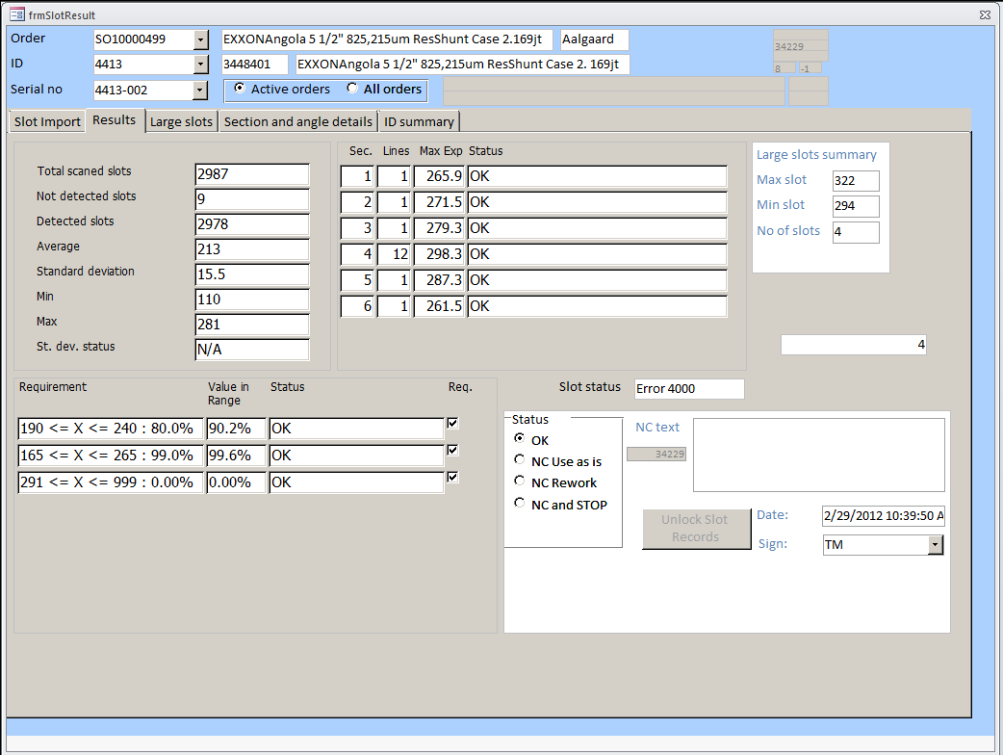

#### Large Slots Tab

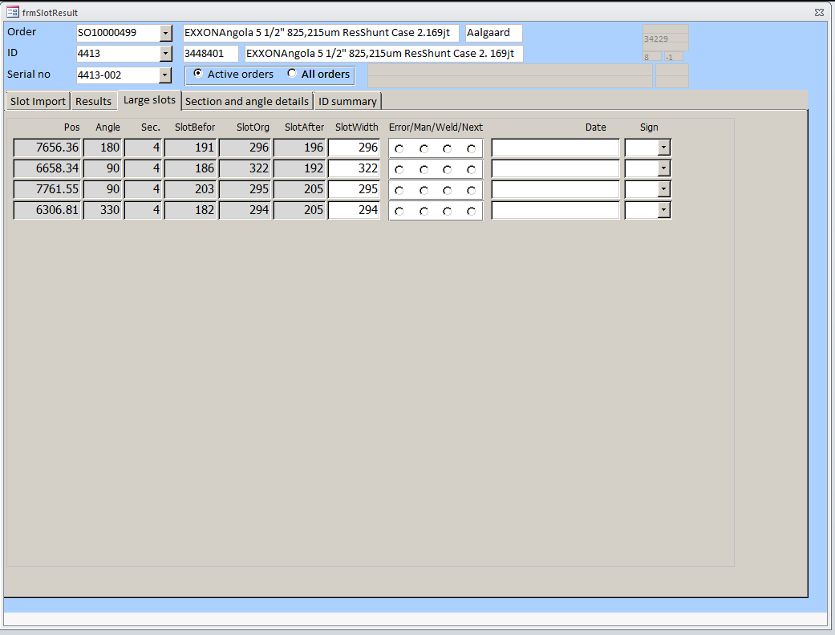

#### Section and Angle Details Tab

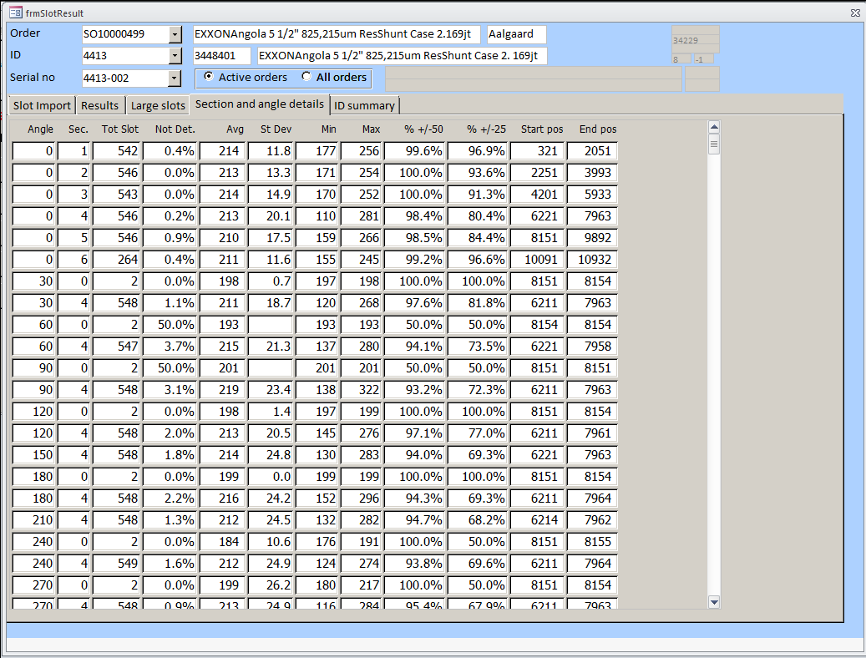

#### ID Summary Tab

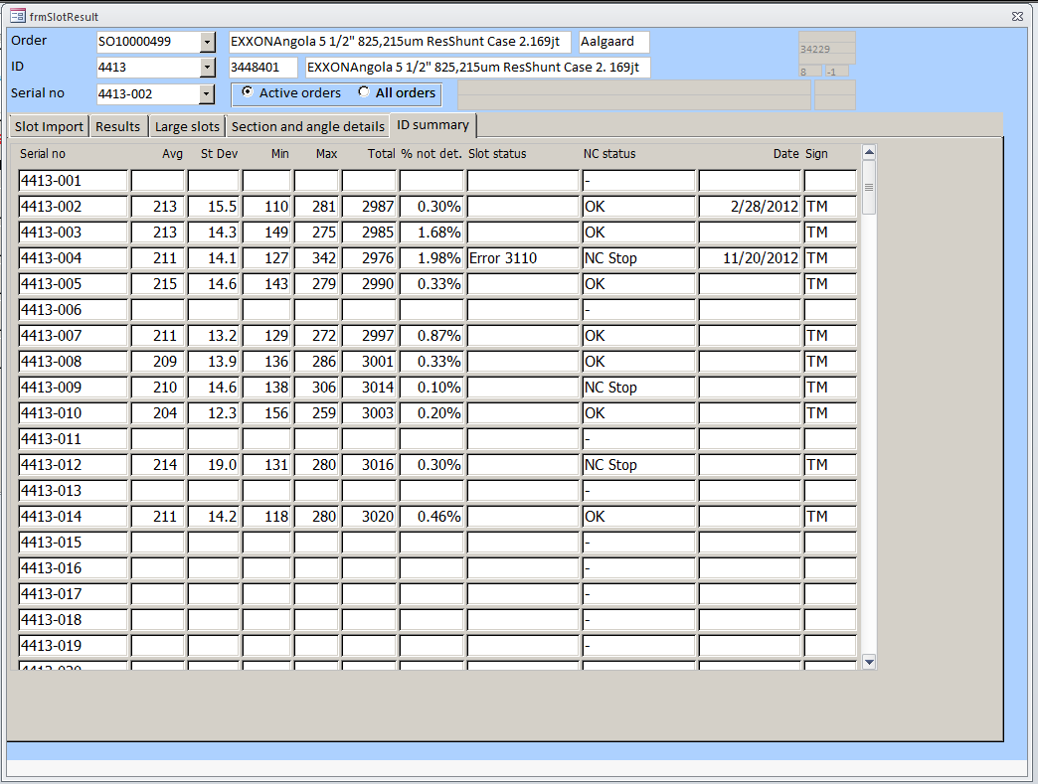

### Order Planning Form Flow



#### Order Tab (Plus Order New & WO New)

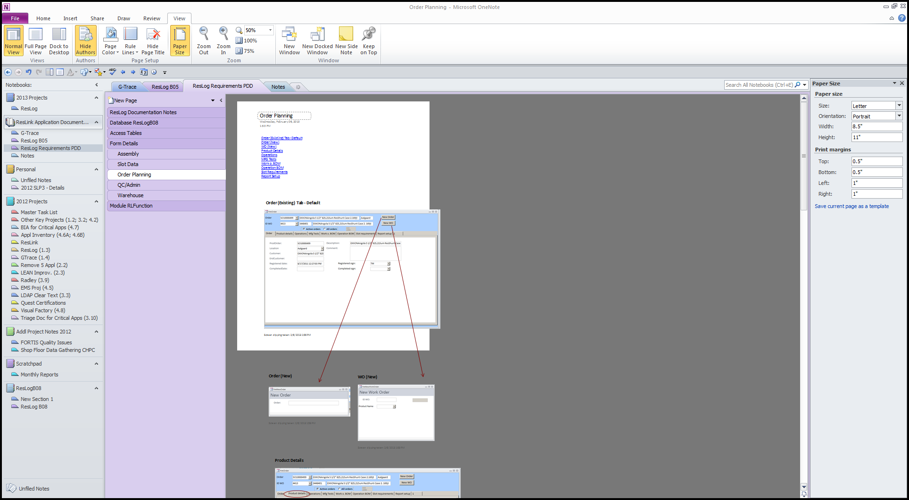

#### Product Details Tab

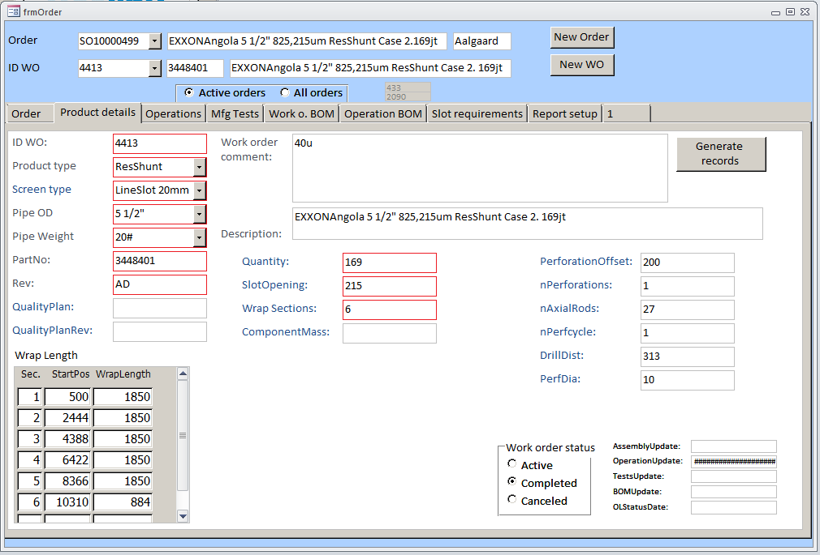

#### Operations Tab

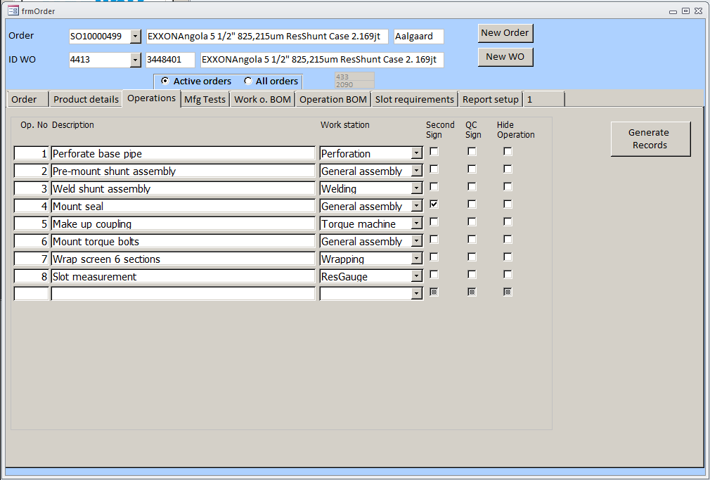

#### MFG Tests Tab

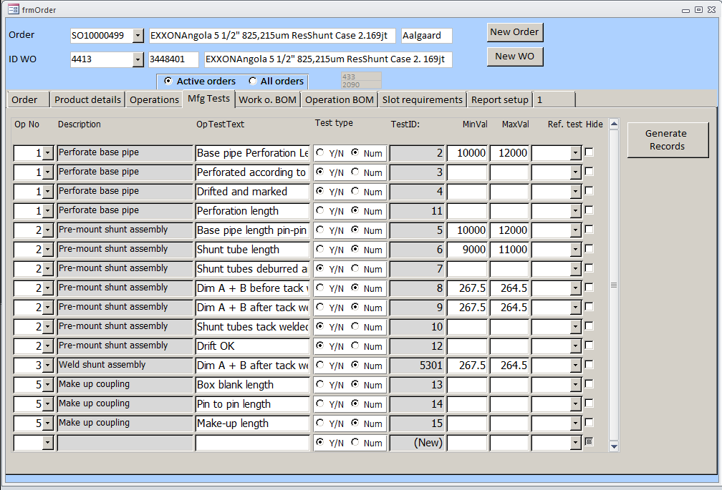

#### Work O. BOM Tab

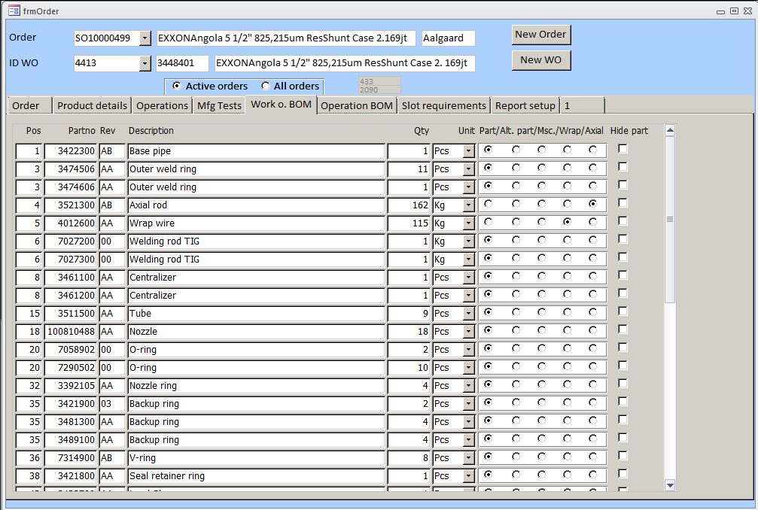

#### Slot Requirements Tab

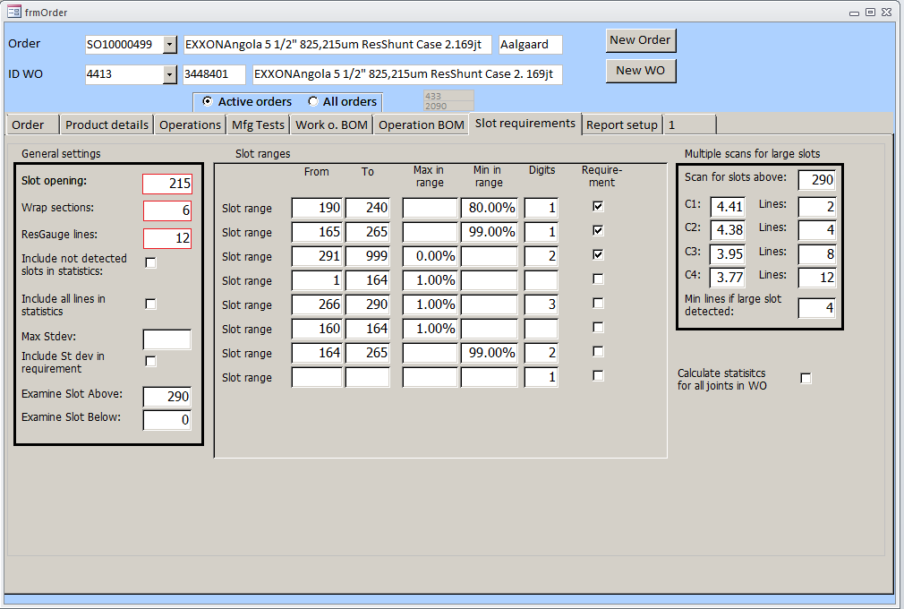

#### Report Setup Tab

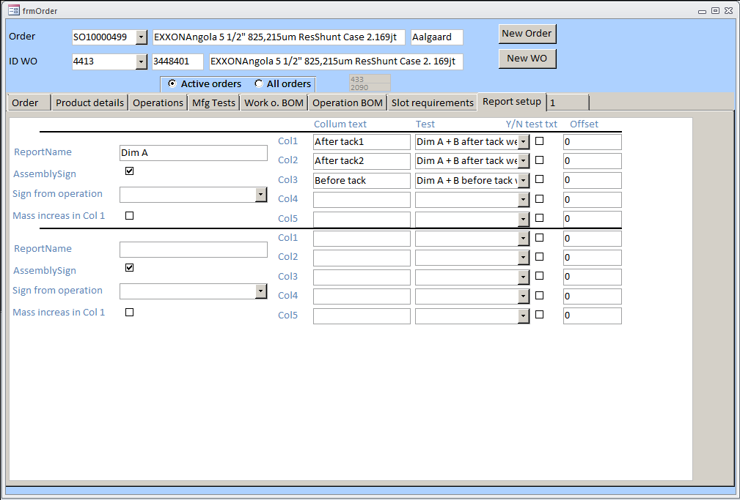

### QC/Admin Form Flow

#### ID Status Tab

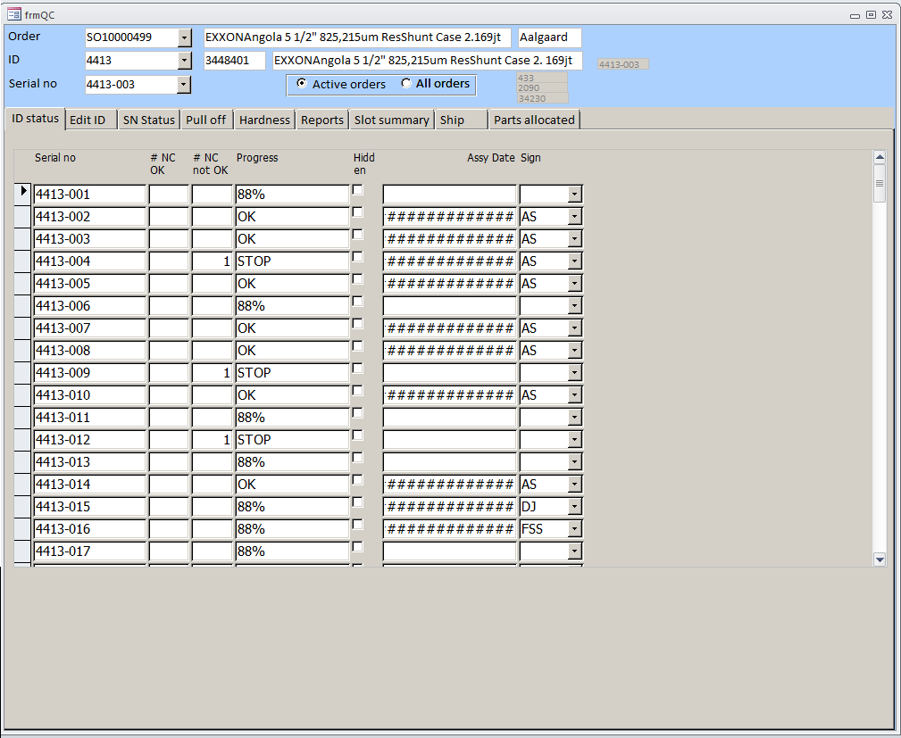

#### Edit ID Tab

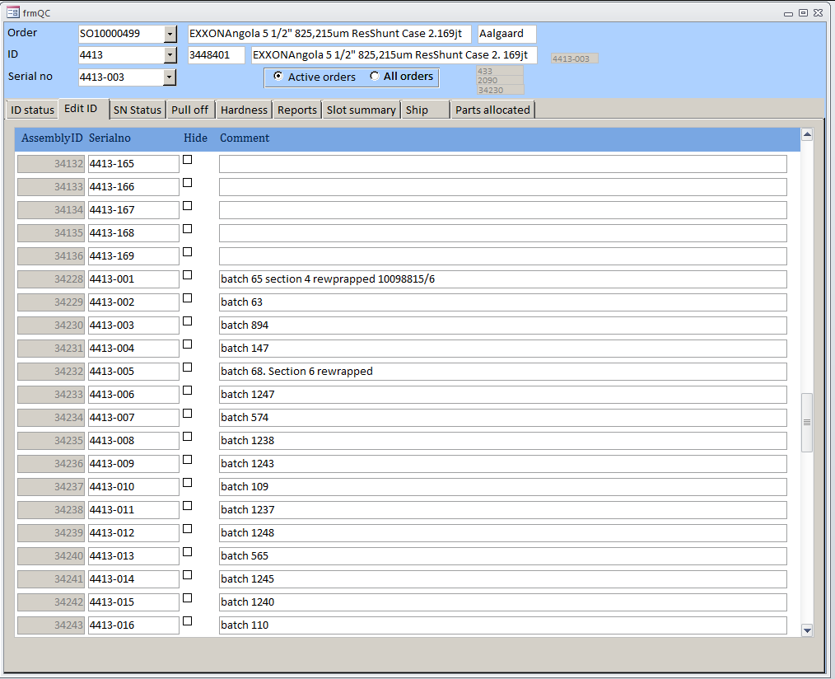

#### SN Status Tab

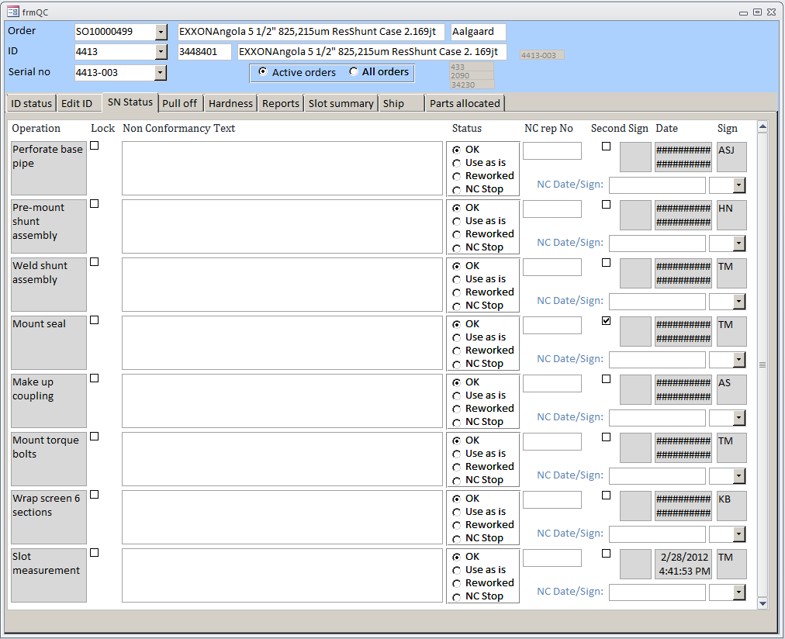

#### Pull Off Tab

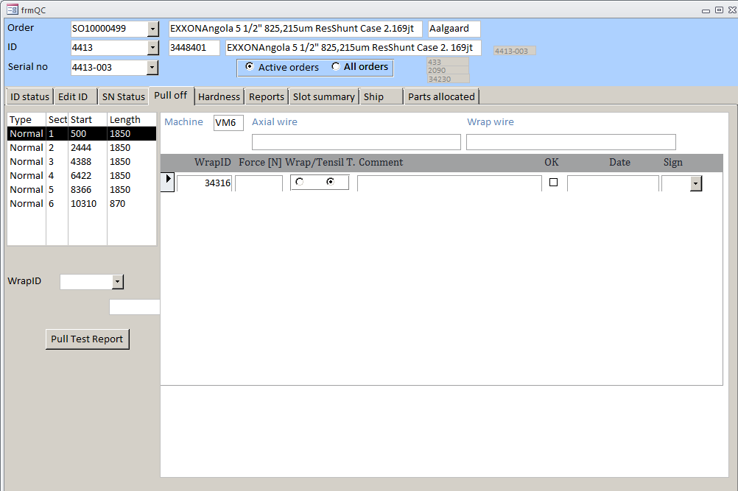

#### Harness Tab

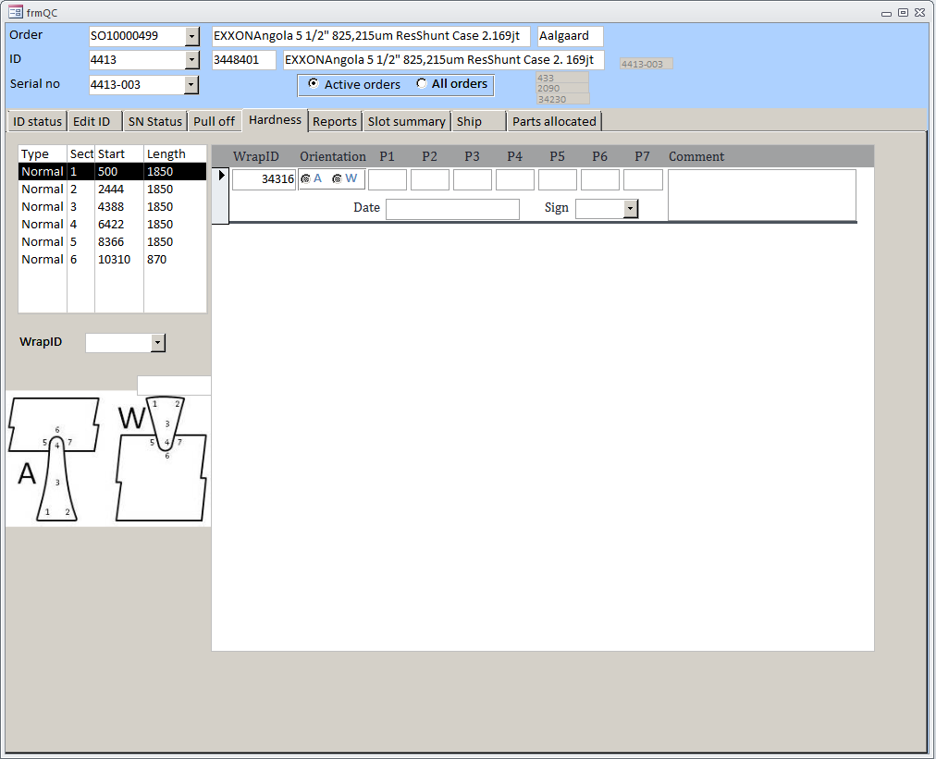

#### Reports Tab

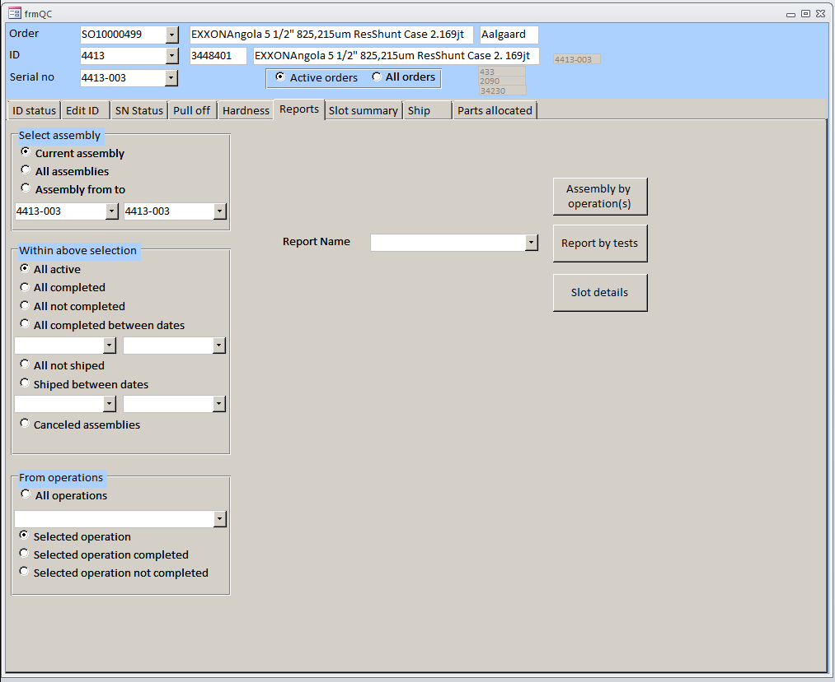

#### Slot Summary Tab

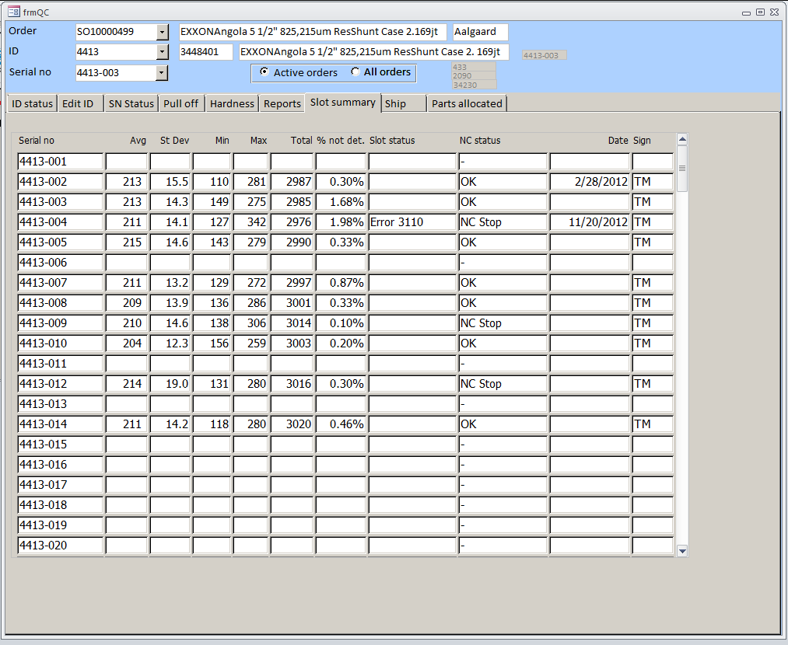

#### Ship Tab

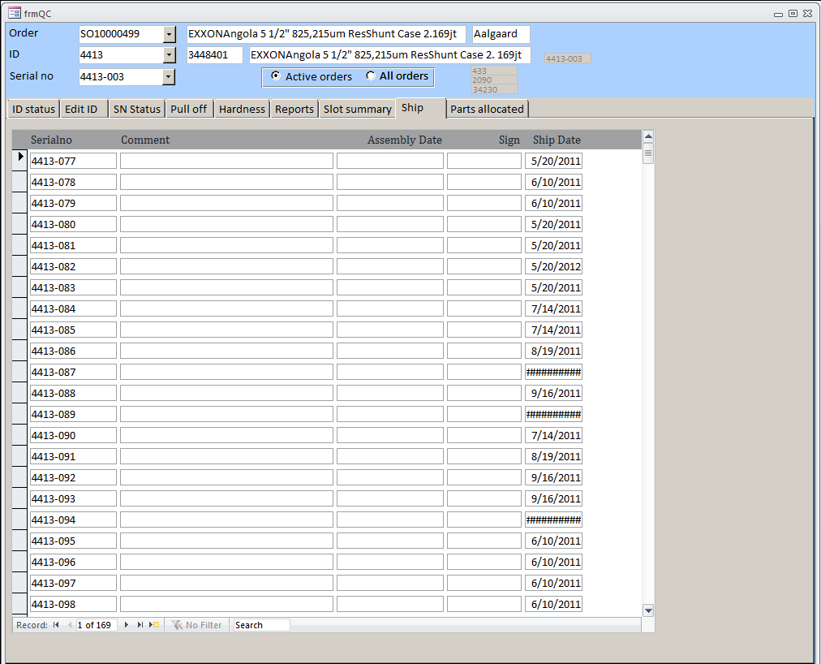

#### Parts Allocated Tab

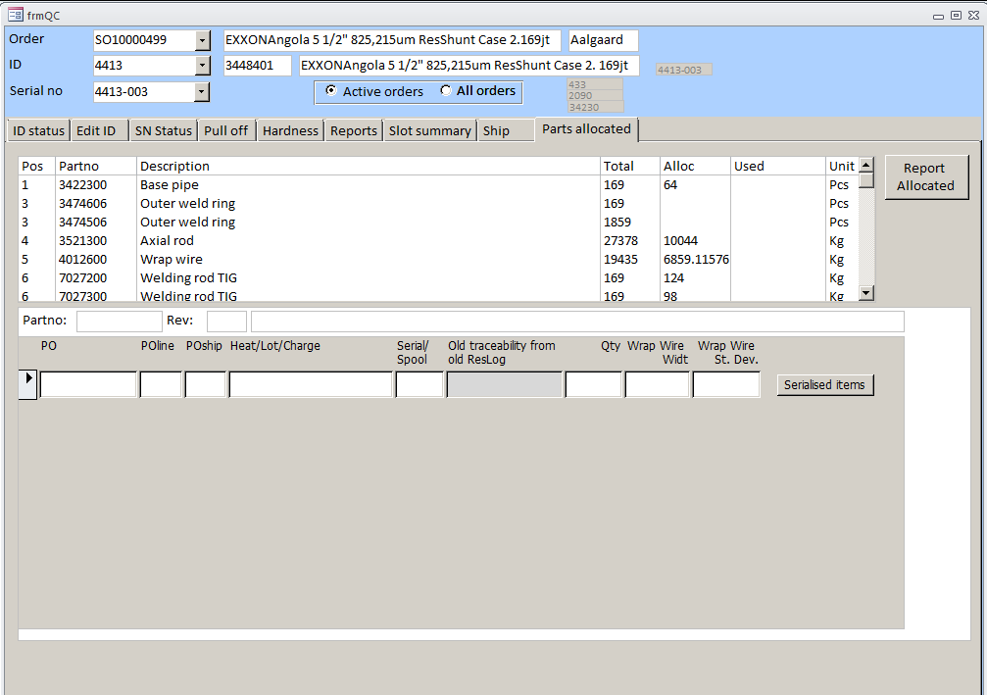

### Ware House Form Flow

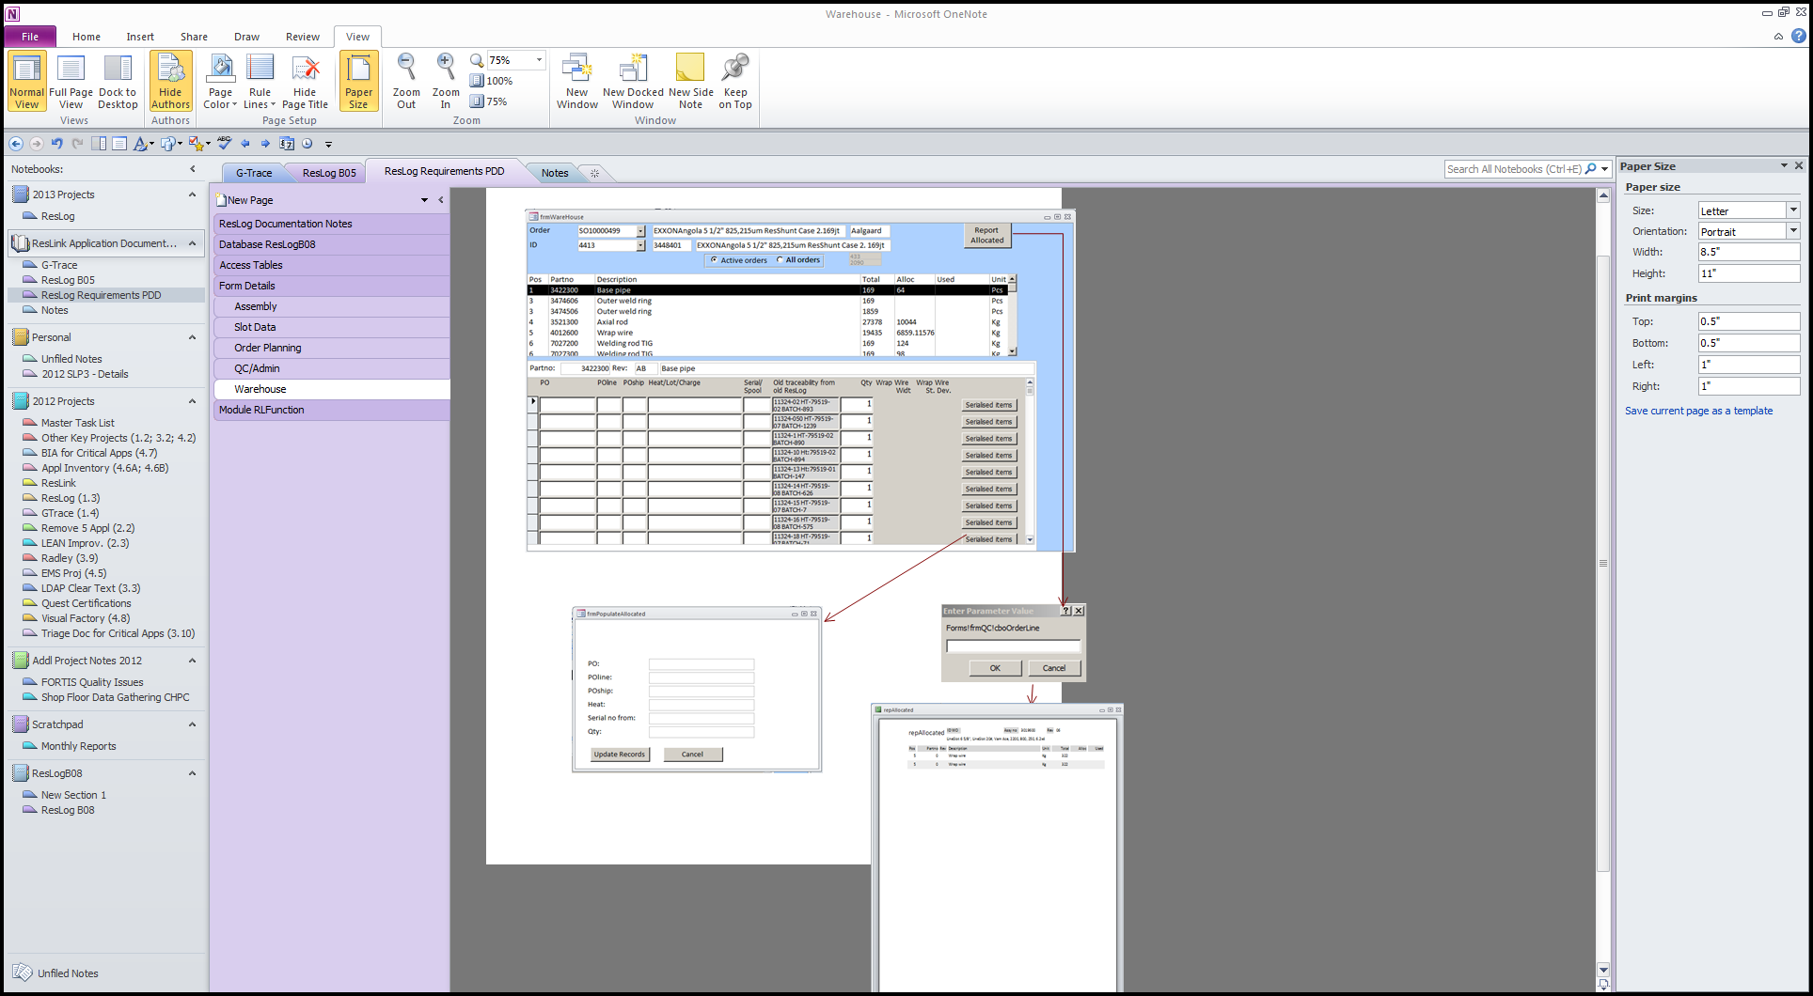

### Module RLFunction

This module contains the special code used within the application.

Please refer to the separate document “RLFunction.txt” for a complete listing of this code.

# Project Plan

## Development Plan

## Development Milestones

# Risks

The ResLog application is currently being revised by the support staff in the Norway product center. These additional fixes and modifications have not been included in this document. This document is based on the ResLogB08 version of ResLog.